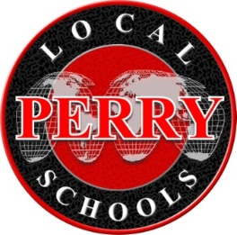

BOE & BAC Joint Statement – 2021

The Perry Board of Education and the Business Advisory Council (BAC) appreciate the opportunity to work together to exchange information and ideas, provide advice regarding the school district’s strategic planning and operations, enhance existing curriculum, and foster support between the school district, businesses, and residents. The district has made significant growth in career exploration opportunities and readiness for our students, thanks in part to valued advice and recommendations of the BAC toward this pursuit. Feedback on crucial skills that our students need to be employable in the region and how to foster increased connections with our business community has been invaluable. The BAC has been advised and provided input for the legislative lobbying efforts of the district that have ensured the schools positions are being heard with consideration. Finally, the financial condition and the future forecast of our schools is a standing item at each meeting.

As we continue our work in the future, it is recommended we increase quantitative measurement tools to assess the level of success in the implementation of actions taken. We hope to continue providing advice and guidance on the employment needs in the community and how this impacts student preparation. In addition, we recommend the BAC keep focused concentration on the economic development of the Perry community and its impact on the financial and strategic actions that the school district will be taking in response. Finally, as we move out of this pandemic, we look forward to refocusing on continuous organizational growth by maintaining a positive culture and learning environment through actions aligned with our aspiring core beliefs and mission statement.

